**WEEK-7 ASSIGNMNETS**

**React-9 HOL:**

import React from 'react';

import ListOfPlayers from './components/ListOfPlayers';

import ScoreBelow70 from './components/ScoreBelow70';

import { OddPlayers, EvenPlayers } from './components/OddEvenPlayers';

import MergedPlayers from './components/MergedPlayers';

function App() {

const flag = true;

const players = [

{ name: 'Jack', score: 50 },

{ name: 'Michael', score: 70 },

{ name: 'John', score: 40 },

{ name: 'Ann', score: 61 },

{ name: 'Elisabeth', score: 61 },

{ name: 'Sachin', score: 95 },

{ name: 'Dhoni', score: 100 },

{ name: 'Virat', score: 84 },

{ name: 'Jadeja', score: 64 },

{ name: 'Raina', score: 75 },

{ name: 'Rohit', score: 80 },

];

const IndianTeam = ['Sachin1', 'Dhoniz', 'Virat3', 'Rohit4', 'Yuvarajs', 'Raina6'];

const T20Players = ['First Player', 'Second Player', 'Third Player'];

const RanjiTrophyPlayers = ['Fourth Player', 'Fifth Player', 'Sixth Player'];

const IndianPlayers = [...T20Players, ...RanjiTrophyPlayers];

if (flag) {

return (

<div>

<h1>List of Players</h1>

<ListOfPlayers players={players} />

<hr />

<h1>List of Players having Scores Less than 70</h1>

<ScoreBelow70 players={players} />

</div>

);

} else {

return (

<div>

<h1>Indian Team</h1>

<h2>Odd Players</h2>

{OddPlayers(IndianTeam)}

<hr />

<h2>Even Players</h2>

{EvenPlayers(IndianTeam)}

<hr />

<h2>List of Indian Players Merged:</h2>

<MergedPlayers IndianPlayers={IndianPlayers} />

</div>

);

}

}

export default App;

**Components:**

import React from 'react';

function ListOfPlayers({ players }) {

return (

<ul>

{players.map((item, index) => (

<li key={index}>

Mr. {item.name} <span>{item.score}</span>

</li>

))}

</ul>

);

}

export default ListOfPlayers;

import React from 'react';

function MergedPlayers({ IndianPlayers }) {

return (

<ul>

{IndianPlayers.map((player, index) => (

<li key={index}>Mr. {player}</li>

))}

</ul>

);

}

export default MergedPlayers;

import React from 'react';

export function OddPlayers([first, , third, , fifth]) {

return (

<ul>

<li>First: {first}</li>

<li>Third: {third}</li>

<li>Fifth: {fifth}</li>

</ul>

);

}

export function EvenPlayers([, second, , fourth, , sixth]) {

return (

<ul>

<li>Second: {second}</li>

<li>Fourth: {fourth}</li>

<li>Sixth: {sixth}</li>

</ul>

);

}

import React from 'react';

function ScoreBelow70({ players }) {

const filtered = players.filter((item) => item.score < 70);

return (

<ul>

{filtered.map((item, index) => (

<li key={index}>

Mr. {item.name} <span>{item.score}</span>

</li>

))}

</ul>

);

}

export default ScoreBelow70;

**Output:**

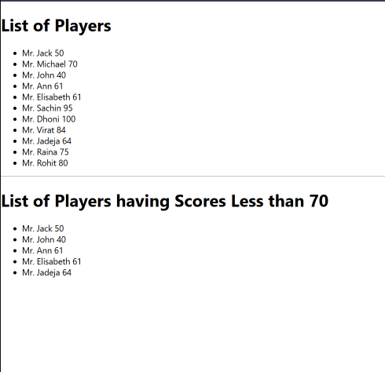

**React-10 HOL:**

import React from "react";

const officeList = [ { Name: "DBS", Rent: 50000, Address: "Chennai" }, { Name: "Regus", Rent: 70000, Address: "Bangalore" }, { Name: "SmartWorks", Rent: 65000, Address: "Mumbai" } ];

function App() { return (

# **Office Space at Affordable Range**

{/* ✅ Load image from public folder */}

{officeList.map((office, index) => {  
 const rentColor = office.Rent <= 60000 ? "red" : "green";  
 return (  
 <div key={index}>  
 <h2>Name: {office.Name}</h2>  
 <h3 style={{ color: rentColor }}>Rent: Rs. {office.Rent}</h3>  
 <h3>Address: {office.Address}</h3>  
 </div>  
 );  
 })}  
</div>

); }

export default App;

**OUTPUT:**

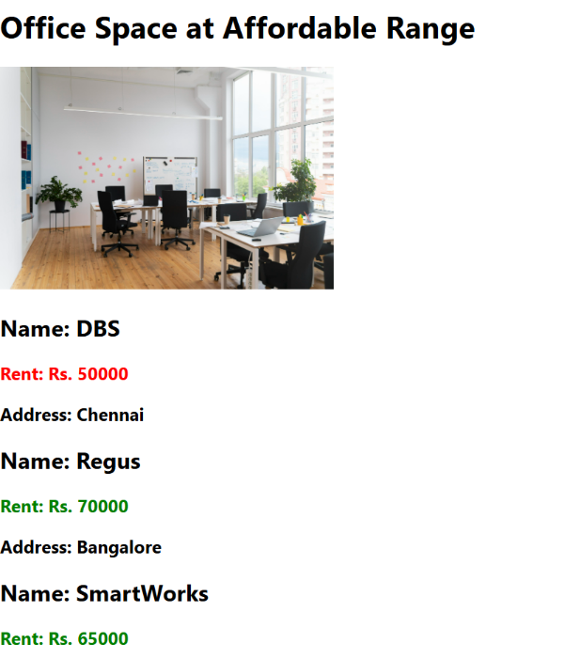

**React-11 HOL:**

import React from "react";

import CurrencyConvertor from "./CurrencyConvertor";

class App extends React.Component {

constructor(props) {

super(props);

this.state = {

counter: 0

};

}

increment = () => {

this.setState({ counter: this.state.counter + 1 });

};

sayHello = () => {

console.log("Hello! You clicked increment.");

alert("Hello from React!");

};

handleIncrementClick = () => {

this.increment();

this.sayHello();

};

decrement = () => {

this.setState({ counter: this.state.counter - 1 });

};

sayWelcome = (msg) => {

alert(msg);

};

handleSyntheticEvent = (e) => {

e.preventDefault(); // Synthetic event

alert("I was clicked");

};

render() {

return (

<div>

<h1>React Events Demo</h1>

<h2>Counter: {this.state.counter}</h2>

<button onClick={this.handleIncrementClick}>Increment</button>{" "}

<button onClick={this.decrement}>Decrement</button>

<br /><br />

<button onClick={() => this.sayWelcome("Welcome to React!")}>

Say Welcome

</button>

<br /><br />

<button onClick={this.handleSyntheticEvent}>Synthetic Event (OnPress)</button>

<br /><br />

<CurrencyConvertor />

</div>

);

}

}

export default App;

**OUTPUT:**

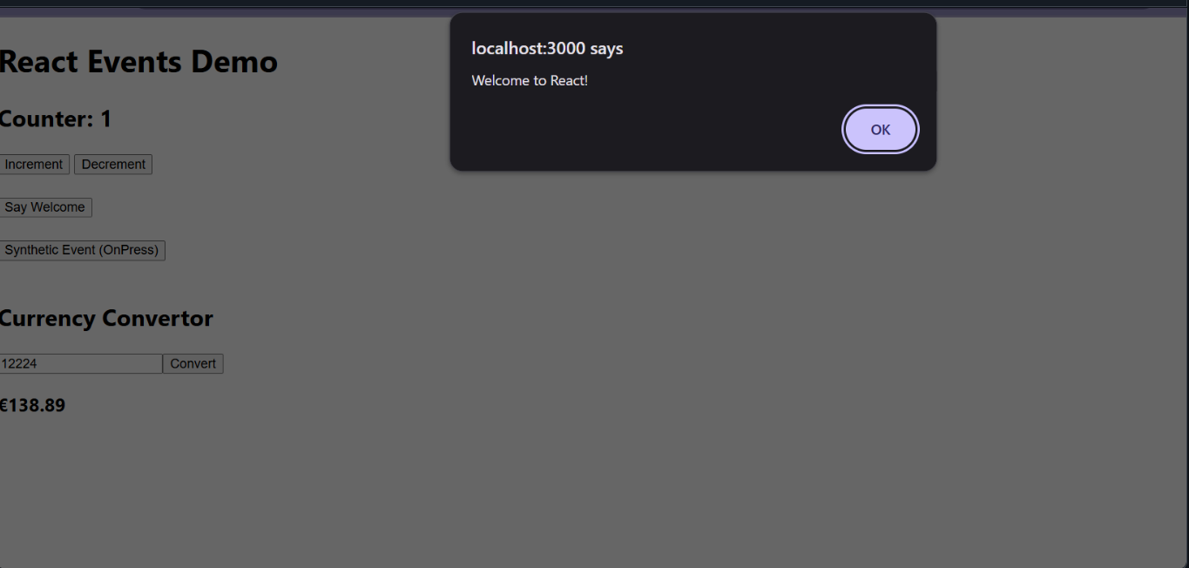

**React-12 HOL:**

import React, { useState } from 'react';

import GuestGreeting from './GuestGreeting';

import UserGreeting from './UserGreeting';

function LoginButton({ onClick }) {

return <button onClick={onClick}>Login</button>;

}

function LogoutButton({ onClick }) {

return <button onClick={onClick}>Logout</button>;

}

function Greeting({ isLoggedIn }) {

if (isLoggedIn) {

return <UserGreeting />;

}

return <GuestGreeting />;

}

function App() {

const [isLoggedIn, setIsLoggedIn] = useState(false);

const handleLoginClick = () => setIsLoggedIn(true);

const handleLogoutClick = () => setIsLoggedIn(false);

return (

<div style={{ padding: '20px' }}>

<h1>✈️ Ticket Booking App</h1>

{isLoggedIn ? (

<LogoutButton onClick={handleLogoutClick} />

) : (

<LoginButton onClick={handleLoginClick} />

)}

<Greeting isLoggedIn={isLoggedIn} />

</div>

);

}

export default App;

**OUTPUT:**

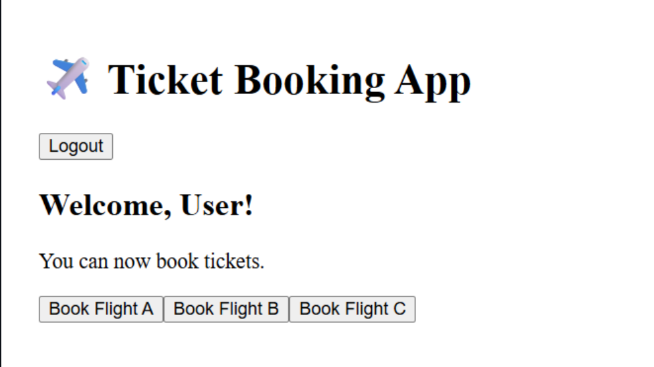

**React-HOL** **13 :**

import React, { useState } from 'react';

import BlogDetails from './Components/BlogDetails';

import BookDetails from './Components/BookDetails';

import CourseDetails from './Components/CourseDetails';

function App() {

const [showBlog, setShowBlog] = useState(true);

const [showCourse, setShowCourse] = useState(true);

return (

<div style={{ padding: '20px' }}>

<button onClick={() => setShowBlog(!showBlog)}>

{showBlog ? "Hide Blog" : "Show Blog"}

</button>

<button onClick={() => setShowCourse(!showCourse)}>

{showCourse ? "Hide Course" : "Show Course"}

</button>

<BookDetails />

<BlogDetails show={showBlog} />

<CourseDetails show={showCourse} />

</div>

);

}

export default App;

**Components:**

import React from 'react';

function BlogDetails({ show }) {

if (!show) return null; // Conditional rendering

return (

<div className="v1">

<h1>Blog Details</h1>

<h3>React Learning</h3>

<h4>Stephen Biz</h4>

<p>Welcome to learning React!</p>

<h3>Installation</h3>

<h4>Schewzdenier</h4>

<p>You can install React from npm.</p>

</div>

);

}

export default BlogDetails;

import React from 'react';

export const books = [

{ id: 101, bname: 'Master React', price: 670 },

{ id: 102, bname: 'Deep Dive into Angular 11', price: 800 },

{ id: 103, bname: 'Mongo Essentials', price: 450 },

];

function BookDetails() {

return (

<div className="st2">

<h1>Book Details</h1>

<ul>

{books.map(book => (

<div key={book.id}>

<h3>{book.bname}</h3>

<h4>{book.price}</h4>

</div>

))}

</ul>

</div>

);

}

export default BookDetails;

import React from 'react';

const courseList = [

{ id: 1, name: "Angular", date: "6/3/20201" },

{ id: 2, name: "React", date: "6/3/20201" },

];

function CourseDetails({ show }) {

if (!show) return null;

return (

<div className="mystyle1">

<h1>Course Details</h1>

{courseList.map(course => (

<div key={course.id}>

<h3>{course.name}</h3>

<p>{course.date}</p>

</div>

))}

</div>

);

}

export default CourseDetails;

**OUTPUT:**

